

School of Electrical and Computer Engineering

Digital Logic Laboratory

Fall 1396

**Experiment #1(sessions 1 to 3)**

**Clock and Periodic Signal Generation**

Sadegh Hayeri - 810194298 – hayerisadegh@gmail.com

Milad Hakimi - 810194306 – milad.hakimi@yahoo.com

**Introduction:** In the first experiment of this course, we started with designing different clock oscillators. Afterwards, we designed a clock (or frequency) divider using counters. In the last session, we used an FPGA for showing the clock counts and setting up things for the next experiments.

**PART II: 1.Ring Oscillator:** For designing a ring oscillator we need inverters, therefore we used the built-in inverters in 74LS04 chip. Connecting the ports as given, the clocked shape waves were Displayed on the oscilloscope(picture 1.I):

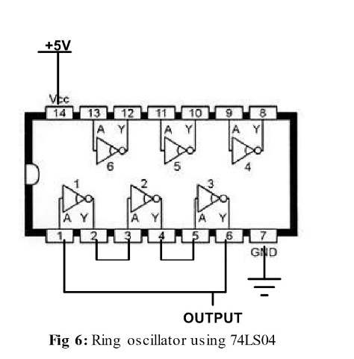

Picture 1.I

**2.LM555 Timer:** Starting with 1KΩ Resistor, the clock pulses were visible at the T=10µs and overshoot occurs in each rising edge of the clock. According to the given equation (T=0.693×(R1+2R2) ×c) the period of each square wave is computed with the equation and compared with the T given by the oscilloscope. Similar experiments were done with resistors 10KΩ and 100KΩ respectively. The changes were applied to the R2 resistor. (The pin connection of LM555 chip is as below)

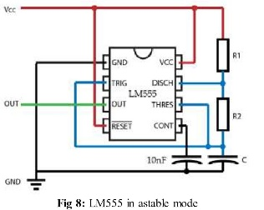

R2=1KΩ , computed T=2.07µS measured T= $\frac{10}{4.3}=2.32µS$ ( Picture 2.I)

R2=10KΩ , computed T=14.55µS measured T= $\frac{50}{3.4}=14.70µS$ ( Picture 2.II)

R2=100KΩ , computed T= 139.29µS measured T= $\frac{500}{3.4}=147.05µS$ (Picture 2.III)



Picture 2.I t=10µs Picture 2.II t=50µs Picture 2.III t=500µs

**3.Smchitt Inverter Oscillator:** After connecting the ports as instructed, overshoot occurs in each rising edge of clock. What is more is that at each falling edge of clock, undershoot also occurs. For having a 500Ω resistor, we connected two 1kΩ resistors parallelly. After debugging the circuit, the α parameter is measured accordingly.

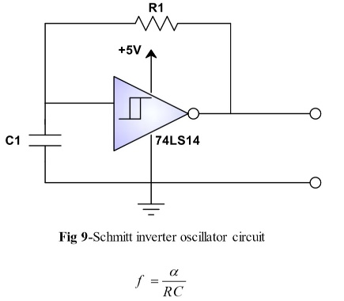

R=500Ω , T= , f=1.5×106 , α=1.5×106×500×10-9 = 0.75 (Picture 3.I)

R=1KΩ , T= , f=8×105 , α=8×105×1000×10-9 = 0.8 (Picture 3.II)

R=2KΩ , T= , f=4×105 , α=4×105×2000×10-9 = 0.8 (Picture 3.III)



Picture 3.I t=5µs Picture 3.II t=10µs Picture 3.III t=20µs

**4.Synchournous Counter as Frequency Divider:** For this part, we used a ring oscillator as clock generator. The frequency of clock generator is 12MgH(T=83). After assembling the circuit as instructed (picture 4.I), the counter begins counting until the MAX (or cout) becomes one. After that, the counter loads with the given value (the counter should divide by 113 so it should be loaded with 256-113=143=10001111). The frequency displayed by the oscilloscope is 105.3KHz (picture 4.II). which is close enough to the computed frequency ($\frac{12000}{113}=106.3$). Note that the pin 13 is connected to the load of counters instead of pin 12(because it is active low).

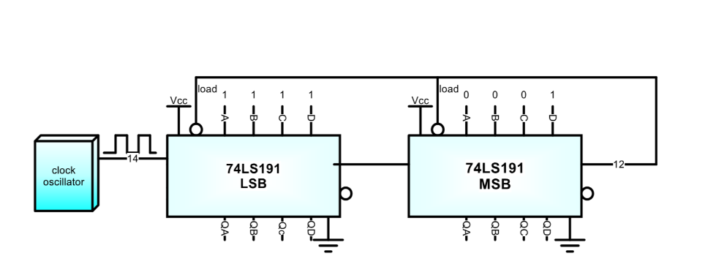

Picture 4.I MSB stands for most significant block and LSB stands for least significant block



Picture 4.II 1/Δx indicates the distance between two Max Values

**PART III:** In this part, a FPGA is used to show the clock counts. To do so, first we assembled the voltage converter to board as instructed (picture I). The reason is that the FPGA works with 3.3V while the voltage on the board is 5V (picture II shows the output of voltage converter). The 74LS74 chip has two built-in D-type flip flops (picture III). By using one of them we made a Toggle Flip Flop (because the concept is to toggle each time the Max becomes one). We used ring oscillator as the clock generator of the system. After that we ran the given Verilog code using Quartus and loaded it on board. The board that we are using is cyclone 2. The pin assignment is done according to the picture IV. The counter is loaded with the value of 11001110=206(picture V shows the schematic of the circuit). Overall the frequency of the circuit is 202.7KHz (which should be doubled because the frequency counts the half of it that the FPGA shows). Keep in mind that the T of the clock generator is 50ns. According to the given numbers the computed number is $\frac{50000}{405.4}=123.24$ which is close enough to the number that FPGA shows. (picture VI and the number is 123)

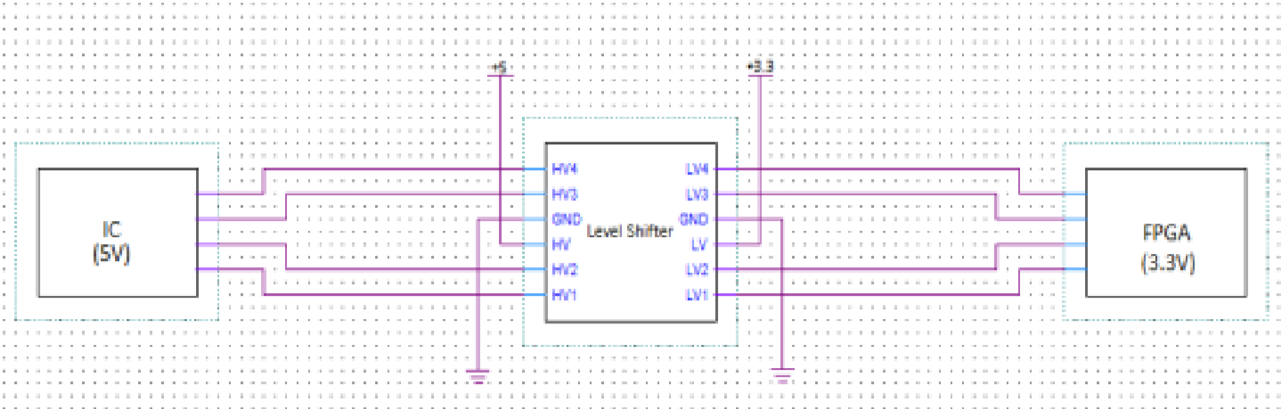

Picture I



Picture II the output of voltage converter

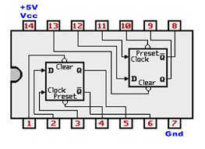

Picture III 74ls74 construction and pin layouts

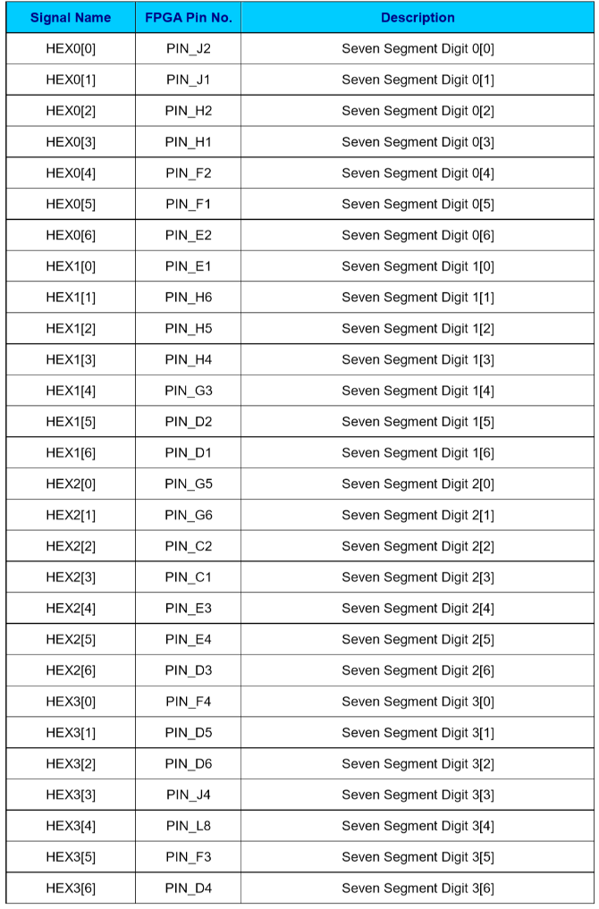

Picture IV pin assignments of 7-segment display

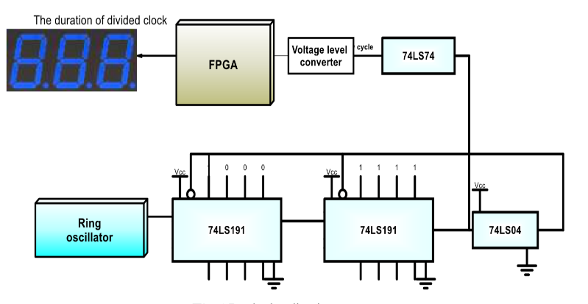

Picture V. Note that instead of using the74LS04 chip as an inverter, we connected the pin 13 to the load because it is active low

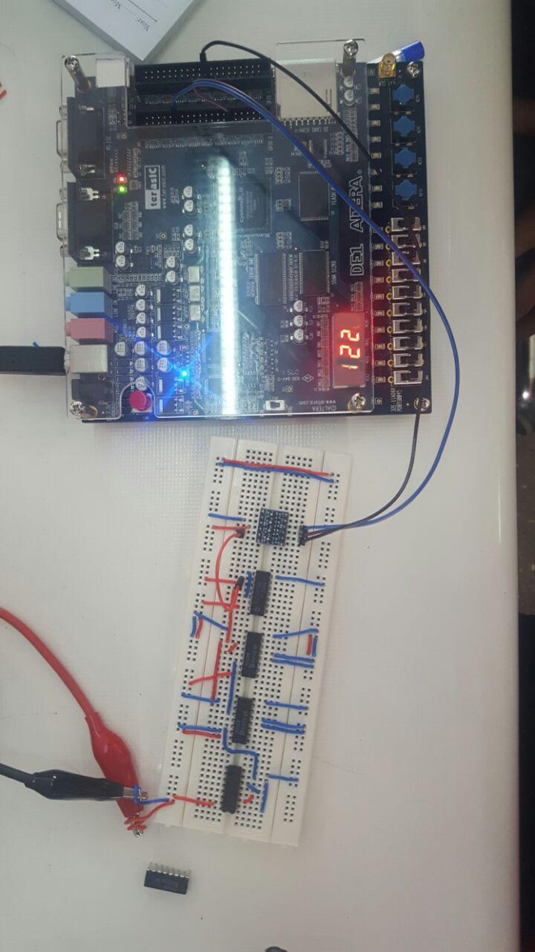

Picture V The number showed by FPGA is constantly changing between 122 and 123